- Go to the Start Button 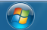 and click Devices and Printers.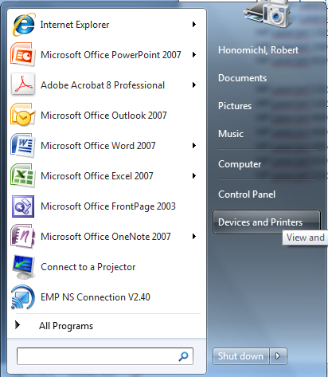
- Click Add a Printer at the top of the screen.
- Then choose add a Local Printer and click next. 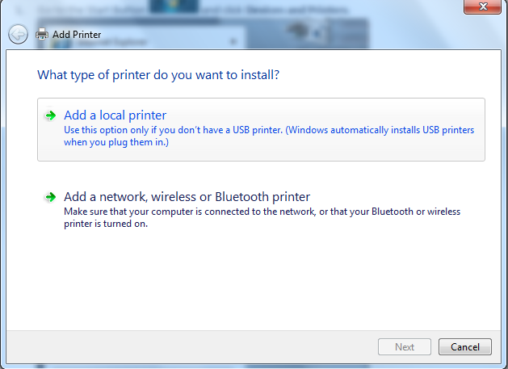
- Choose Create a new port and from the drop down box choose Standard TCP/IP Port and then click Next.
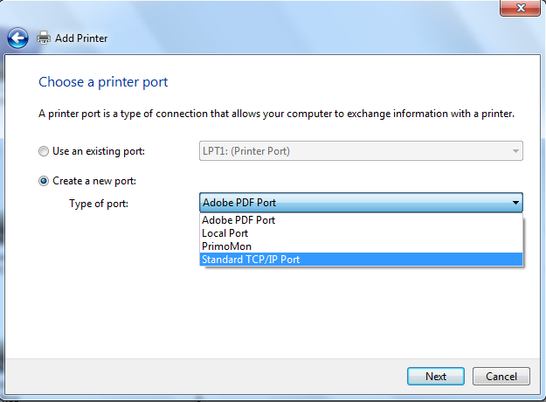
- Type in the IP address of the printer that you want to install in Hostname or IP address the port name will automatically populate. Leave the check box checked and then click next. There is a list of them at the bottom of the page.
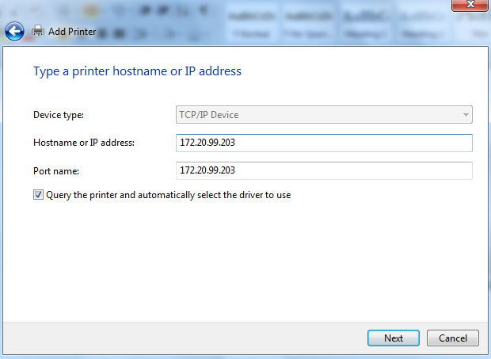
- When the Type a printer name pops up you can type what name you want the printer in your list of printers. Otherwise it will just be the type of printer. After that click next. 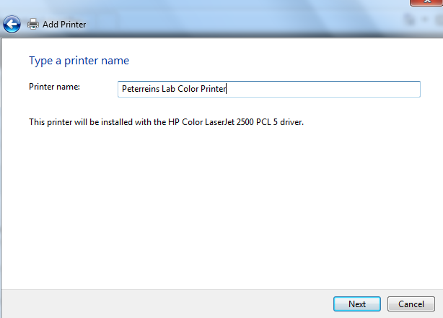
- Select Do not share this printer and click next. 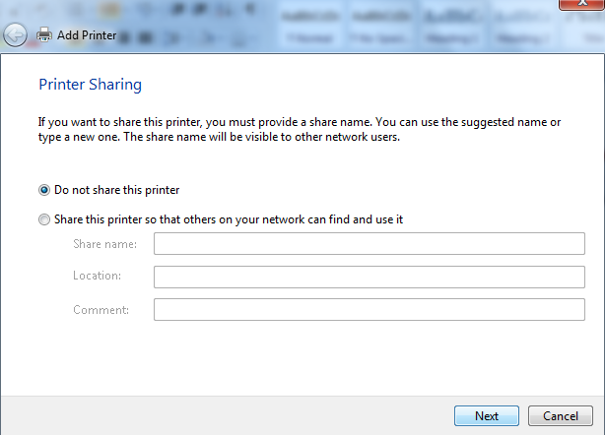
- Decide if you want this to be your default printer and then click Finishl. 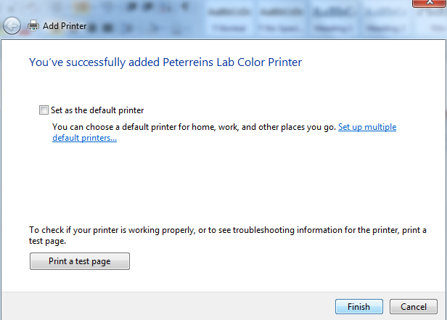

HP Color Laserjet 2500 - tech lab - 172.20.99.203 (Peterreins)
HP Color Laserjet 3800 - Lab 136 - 172.20.98.90 (Lab 136)
HP Laserjet 1320 - room 109 - 172.20.99.215 (Room 112 Decurtins)
HP Laserjet 2300L - MS Library - 172.20.98.82
HP Laserjet 4100 - North Wing - 172.20.99.219

HP Laserjet 1320 - autotech 1 - 172.20.96.70 (AutoShop)
HP Laserjet 1320 - autotech 2 - 172.20.96.71 (Lora Milne)
HP Laserjet 4000 - HS B5 - 172.20.99.210 (Olson)
HP Laserjet 4000 - HS E2 - 172.20.99.206 (Bierschbach)
HP Laserjet 4050 - HS SPED - 172.20.96.146 (Haug)
HP Laserjet 4100 - G3 (counselors) - 172.20.99.204 (Social Studies Office)
HP Laserjet 1320 - HS Room A2 - 172.20.99.201 (Kraai)

